EE 1004 Foundation of Information Systems and Data Analysis

Semester A 2023/24

Part II -- Exercise 01

**Question 1**

Consider the following figure, Write down:

(i) the set of nodes **V(G)** and edges **E(G)** (iv) the degree of each node

(ii) the order and size of graph (v) the total degree of graph

(iii) the neighborhood of each node

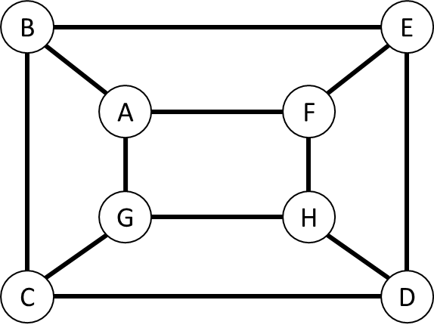

**Ans:**

(i) V(G) = {A, B, C, D, E, F, G, H}

E(G) = {BC, CD, DE, EB, AF, FH, HG, AG, AB, EF, HD, CG} or

{(B,C), (C,D), (D,E), (E,B), (A,F), (F,H), (H,G), (A,G), (A,B), (E,F), (H,D), (C,G)}

(ii) Order = $\left|V\right|$ = 8

Size = $\left|E\right|$ =12

(iii) N(A) = {B, G, F} N(E) = {B, D, F}

N(B) = {A, E, C} N(F) = {A, E, H}

N(C) = {G, B, D} N(G) = {A, H, C}

N(D) = {C, E, H} N(H) = {D, F, G}

(iv) Degree(A) = Degree(B) = Degree(C) = Degree(D) = Degree(E) = Degree(F) = Degree(G) = Degree(H) = 3

(v) Total Degree = 24

**Question 2**

Consider the following relationship:

(i) John likes Joan, Jean, and Jane;

(ii) Joe likes Jane and Joan;

(iii) Jean and Joan like each other.

Draw a digraph illustrating these relationships between John, Joan, Jean, Jane, and Joe, and Write down the number of vertices, edges, and the degree of each vertex

**Ans:**

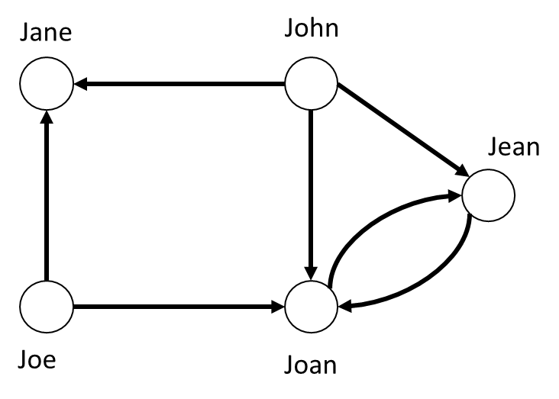

$\left|V\right|=5$ ($∵V=\{John, Joan, Jean, Jane, Joe\}$) $\left|E\right|=7$

Degree (John) = 3 (Out-degree = 3)

Degree (Joan) = 4 (In-degree = 3, Out-degree = 1)

Degree (Jean) = 3 (In-degree = 2, Out-degree = 1)

Degree (Jane) = 2 (In-degree = 2)

Degree (Joe) = 2 (Out-degree = 2)

**Question 3**

Draw the following graphs:

(i) the complete graph K6;

(ii) the complete bipartite graph K2,4

And determine the number of edges on each graph.

**Ans:**

(i) 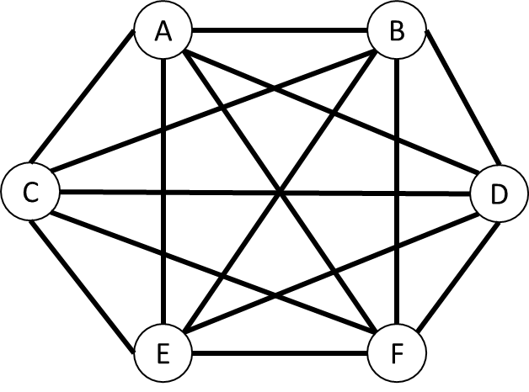 $∵complete graph K_{6} ∴\left|E\right|=\frac{n\left(n-1\right)}{2}=\frac{6\left(5\right)}{2}=15$

(ii) 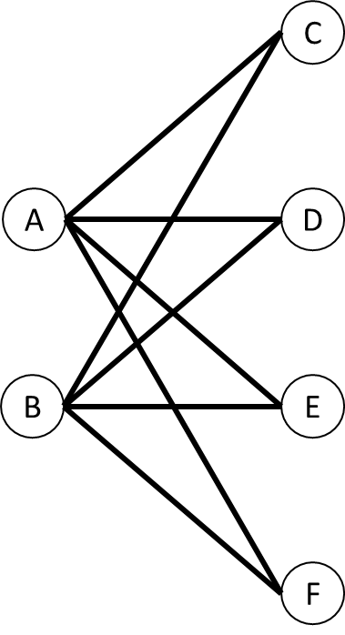 $∵complete bipartite graph K_{2,4} ∴\left|E\right|=rs=2×4=8$

**Question 4**

Identify which two of the following graphs are isomorphic, and give the justification(s)

|  |  |  |  |
| --- | --- | --- | --- |
|  |  |  |  |
| (a) | (b) | (c) | (d) |

**Ans:**

Graph (a) & (d), since:

* Same order and size of both graphs:
$$\left|E\right|=7, \left|V\right|=5$$

* Same edge connectivity:

$$Graph \left(a\right):\{(1→2), (2→3), (2→5), (4→3), (4→5), (5→1), (5→3)\}$$

$$Graph \left(d\right):\{(1→2), (2→3), (2→5), (4→3), (4→5), (5→1), (5→3)\}$$

**Question 5**

Show how the graph in the following figure can be drawn in the plane without crossings

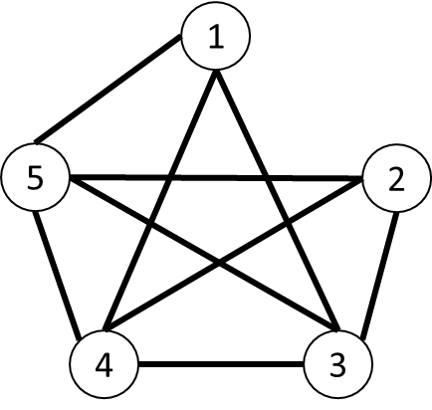

**Ans:**

(Any Reasonable Solutions)

|  |  |
| --- | --- |
|  |  |
| Possible Solution 1 | Possible Solution 2 |

The solution should have **same number of nodes** and **same edge connectivity**

* Node 1: {(1,3), (1,4), (1,5)}
* Node 2: {(2,3), (2,4), (2,5)}
* Node 3: {(3,1), (3,2), (3,4), (3,5)}
* Node 4: {(4,1), (4,2), (4,3), (4,5)}
* Node 5: {(5,1), (5,2), (5,3), (5,4)}

**Question 6**

Draw all the spanning trees in the following graph (hints: there are totally 8 spanning trees)

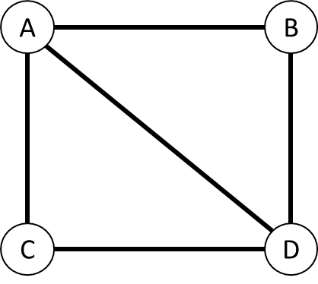

**Ans:**

|  |  |
| --- | --- |
|  |  |
|  |  |
|  |  |
|  |  |

**Question 7**

With 5 vertices and 8 edges, draw:

(i) a simple graph;

(ii) a general graph with no loops;

(iii) a general graph with no multiple edges

**Ans:**

(Any reasonable solution)

|  |  |  |
| --- | --- | --- |
|  |  |  |
| (i) | (ii) | (iii) |

**Question 8**

In the Petersen graph shown in follow, find:

(i) a trail of length 5;

(ii) a path of length 9;

(iii) cycles of lengths 5, 6, 8, and 9;

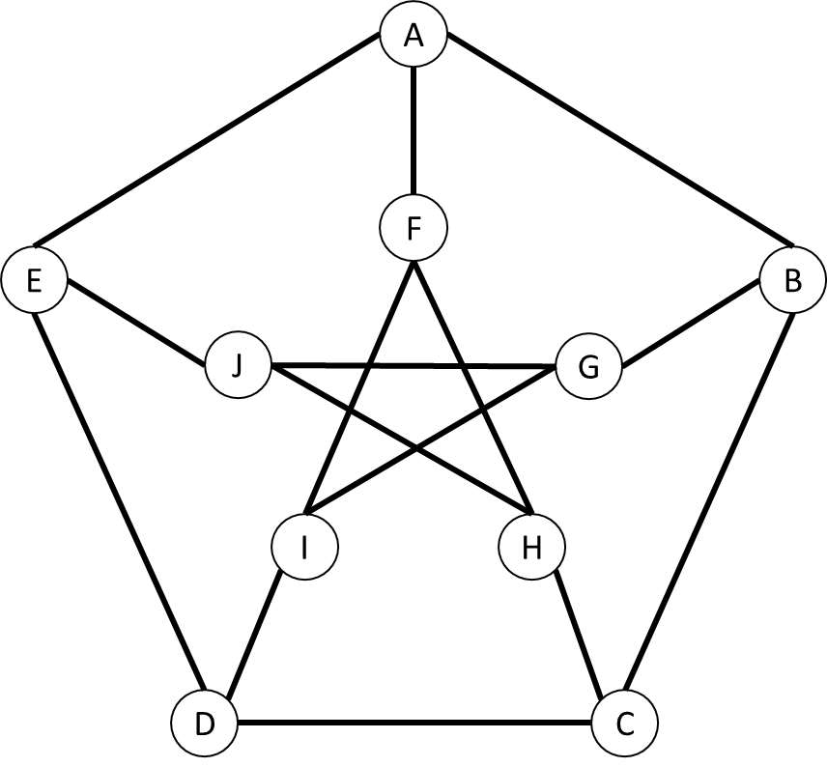

**Ans:**

(Any Reasonable Solution)

(i) Trail = $A→B→C→D→E→J$

(ii) Path = $A→B→C→D→E→J→H→F→I→G$

(iii) Cycle of length 5 = $A→B→C→D→E→A;$

Cycle of length 6 = $A→B→C→D→I→F→A;$

Cycle of length 8 = $A→B→C→D→E→J→H→F→A;$

Cycle of length 9 = $A→B→C→D→E→J→G→I→F→A;$

**Question 9**

Draw the adjacency matrices for the complete bipartite graph K3,4

**Ans:**

|  |  |  |
| --- | --- | --- |
| K3,4 |  |  |

Note that: Any adjacency matrix of complete bipartite graph Kr,s can be written as

$$\left(\begin{matrix}0_{r×r} & A_{r×s} \\ A_{s×r} & 0_{s×s}\end{matrix}\right)$$

Where $0_{r×r}$ and $0_{s×s}$ are the null matrices with dimensions of $r×r$ and $s×s$ respectively, and $A_{r×s}$ is the **transpose** of $A_{s×r}={\left(A_{r×s}\right)}^{-1}$